**DAILY ONLINE ACTIVITIES SUMMARY**

|  |  |  |  |  |  |  |  |  |
| --- | --- | --- | --- | --- | --- | --- | --- | --- |
| **Date:** | **22/05/2020** | | | | | **Name:** | **ASHIKA** | |
| **Sem & Sec** | **6th sem ‘A”** | | | | | **USN:** | **4AL17CS016** | |
| **Online Test Summary** | | | | | | | | |
| **Subject** | | **OR** | | | | | | |
| **Max. Marks** | | **30** | | **Score** | | | **30** | |
| **Certification Course Summary** | | | | | | | | |
| **Course** | **Ethical hacking** | | | | | | | |
| **Certificate Provider** | | | **Great learning** | | **Duration** | | | **6 HOUR** |
| **Coding Challenges** | | | | | | | | |
| **Problem Statement: NO** | | | | | | | | |
| **Status: Introduction to ethical hacking and demonstration** | | | | | | | | |
| **Uploaded the report in Github** | | | | | **yes** | | | |
| **If yes Repository name** | | | | | <https://github.com/ASHIKA-05/online-report3> | | | |
| **Uploaded the report in slack** | | | | | **yes** | | | |

Subject: OR



CERTIFICATION COURSE: INTRODUCTION TO ETHICAL HACKING

DEMONSTRATION

1.career and growth Ladder in Ethical Hacking

2.AGENDA

.ethical hacking domains

.web application domain

.mobile

.Network Architecture Domain

.Demonstration

.ethical hacking in web application secutity

3.DOMAINS UNDER ETHICAL HACKING

.web application domain

.mobile

.Network architecture domain



CODING:

1.Write a Java Program to find the largest and smallest word in a string.

Description:  
ALGORITHM  
STEP 1: START  
STEP 2: DEFINE String string="Hardships often prepare ordinary people for an extraordinary destiny"  
STEP 3: DEFINE word = " ", small = " ", large = " ".  
STEP 4: Make object of String[] words.  
STEP 5: SET length =0  
STEP 6: string = string + " "  
STEP 7: SET i=0. REPEAT STEP 8 to 9 STEP UNTIL i  
STEP 8: IF(string.charAt(i) != ' ') then  
word =word + string.charAt(i)  
else  
word[length]=word  
length =length + 1  
word = " "  
STEP 9: i=i+1  
STEP 10: small = large =words[0]  
STEP 11: SET k = 0. REPEAT STEP 12 to STEP 14 UNTIL k  
STEP 12: IF(small.length() > words[k].length())  
then  
small = words[k]  
STEP 13: IF(large.length() < words[k].length())  
then  
large = words[k]  
STEP 14: k = k + 1  
STEP 15: PRINT small  
STEP 16: PRINT large  
STEP 17: END

public class Main {

public static void main(String[] args){

String string = "Hardships often prepare ordinary people for an extraordinary destiny";

String word = "", small = "", large="";

String[] words = new String[100];

int length = 0;

string = string + " ";

for(int i = 0; i < string.length(); i++){

if(string.charAt(i) != ' '){

word = word + string.charAt(i);

}

else{

words[length] = word;

length++;

word = "";

}

}

small = large = words[0];

for(int k = 0; k < length; k++){

if(small.length() > words[k].length())

small = words[k];

if(large.length() < words[k].length())

large = words[k];

}

System.out.println("Smallest word: " + small);

System.out.println("Largest word: " + large);

} }

**Output:**

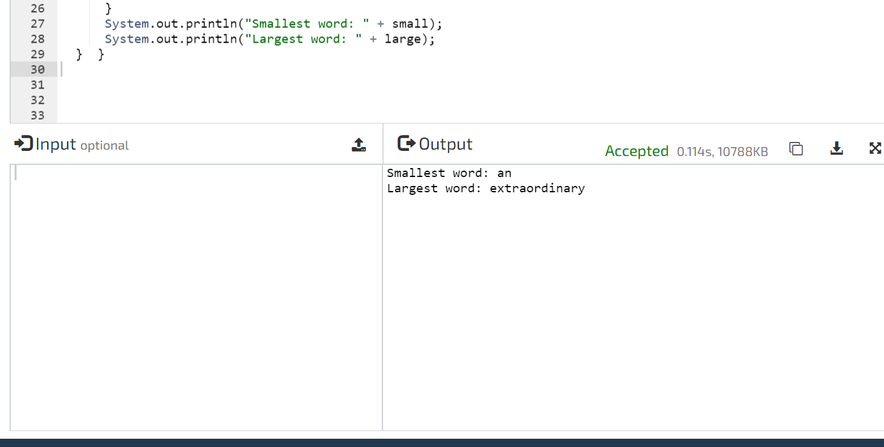

2.Write a Java Program to separate the Individual Characters from a String

Description:  
In computer science, collection of characters including spaces is called as string. To separate an individual character from the string, individual characters are accessed through its index.

Algorithm  
STEP 1: START  
STEP 2: DEFINE String string = "characters "  
STEP 3: PRINT "Individual characters from given string: "  
STEP 4: SET i=0. REPEAT STEP 5 to STEP 6 UNTIL i<string.length()  
STEP 5: PRINT string.charAt(i)  
STEP 6: i=i+1  
STEP 7: END

public class Main

{

public static void main(String[] args) {

String string = "characters";

//Displays individual characters from given string

System.out.println("Individual characters from given string:");

//Iterate through the string and display individual character

for(int i = 0; i < string.length(); i++){

System.out.print(string.charAt(i) + " ");

}

}

}

**Output:**

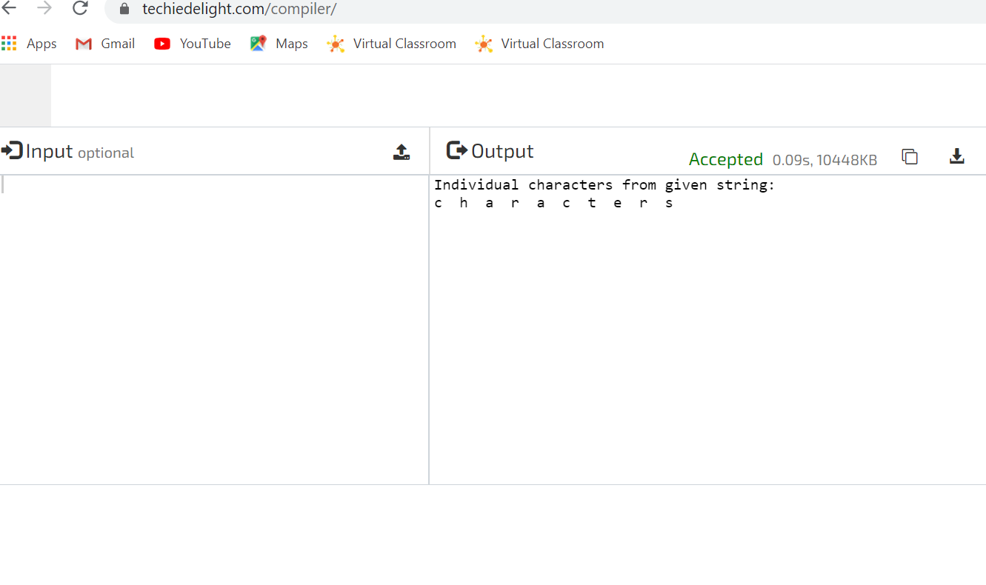

3.Write a C Program to implement various operations of Singly Linked List Stack.

include <stdio.h>

#inclu#de <stdlib.h>

struct node

{

int info;

struct node *ptr;

}*top,*top1,*temp;

int topelement();

void push(int data);

void pop();

void empty();

void display();

void destroy();

void stack_count();

void create();

int count = 0;

void main()

{

int no, ch, e;

printf("\n 1 - Push");

printf("\n 2 - Pop");

printf("\n 3 - Top");

printf("\n 4 - Empty");

printf("\n 5 - Exit");

printf("\n 6 - Dipslay");

printf("\n 7 - Stack Count");

printf("\n 8 - Destroy stack");

create();

while (1)

{

printf("\n Enter choice : ");

scanf("%d", &ch);

switch (ch)

{

case 1:

printf("Enter data : ");

scanf("%d", &no);

push(no);

break;

case 2:

pop();

break;

case 3:

if (top == NULL)

printf("No elements in stack");

else

{

e = topelement();

printf("\n Top element : %d", e);

}

break;

case 4:

empty();

break;

case 5:

exit(0);

case 6:

display();

break;

case 7:

stack_count();

break;

case 8:

destroy();

break;

default :

printf(" Wrong choice, Please enter correct choice ");

break;

}

}

}

/* Create empty stack */

void create()

{

top = NULL;

}

/* Count stack elements */

void stack_count()

{

printf("\n No. of elements in stack : %d", count);

}

/* Push data into stack */

void push(int data)

{

if (top == NULL)

{

top =(struct node *)malloc(1*sizeof(struct node));

top->ptr = NULL;

top->info = data;

}

else

{

temp =(struct node *)malloc(1*sizeof(struct node));

temp->ptr = top;

temp->info = data;

top = temp;

}

count++;

}

void display()

{

top1 = top;

if (top1 == NULL)

{

printf("Stack is empty");

return;

}

while (top1 != NULL)

{

printf("%d ", top1->info);

top1 = top1->ptr;

}

}

void pop()

{

top1 = top;

if (top1 == NULL)

{

printf("\n Error : Trying to pop from empty stack");

return;

}

else

top1 = top1->ptr;

printf("\n Popped value : %d", top->info);

free(top);

top = top1;

count--;

}

int topelement()

{

return(top->info);

}

void empty()

{

if (top == NULL)

printf("\n Stack is empty");

else

printf("\n Stack is not empty with %d elements", count);

}

void destroy()

{

top1 = top;

while (top1 != NULL)

{

top1 = top->ptr;

free(top);

top = top1;

top1 = top1->ptr;

}

free(top1);

top = NULL;

printf("\n All stack elements destroyed");

count = 0;

}

**Output:-**

